TASK 1: GITHUB COMPLETE

1.Git is a version control device which is used to work on one project by a team without any physical interaction.

2. git is used to revert the changes if any changes create danger for your program functionality.

3. 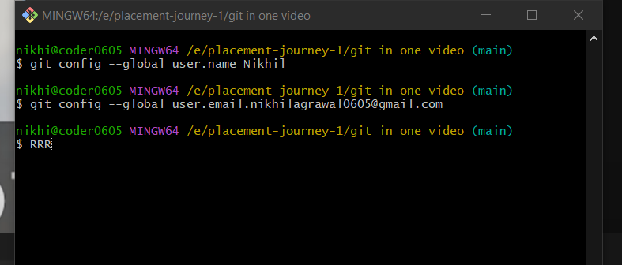

To change the name and email who commited in the repository we used a command name git config –global user. Name/email.



To check that you enter then you use this command.

To open vs code use code .

Cloning comes all data from server while init comes all data from intilsation.

ls – lart used for shown all hidden folders.

Git init used to intilise any folder to git repo.

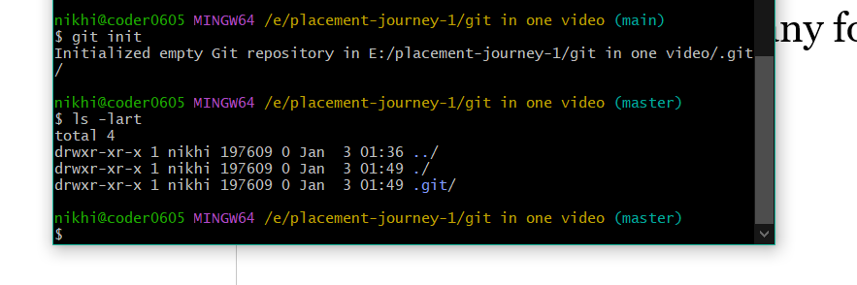

Git status is a command to find status of any repo.